TASK 5
5.1 The application terminated immediately during startup.
Symptom
Running the program produced:
terminate called after throwing an instance of 'char const*'
Aborted
Investigation
The executable was compiled with debug symbols:
g++ -g -std=c++11 *.cpp -o taskforge
GDB was started:
gdb ./taskforge
The program was executed:
run
After the crash, a backtrace was generated:
bt*
Evidence
The backtrace pointed to:
Film::Film() at*Film.cpp:10
Root Cause
The constructor contained:
Film::Film()
{
throw "Not yet implemented";
}
Every Film-derived object triggered this exception during creation.
Correction
The constructor was changed to:

Film::Film()
{
}
Result
The application started successfully and all objects could be created correctly.
5.2 After implementing state transitions, Valgrind reported a memory leak.
Symptom
Valgrind reported:
8 bytes in 1 blocks are definitely lost
Investigation
Used:
valgrind --leak-check=full --show-leak-kinds=all ./taskforge
Valgrind traced the leak back to state allocation in FilmTypes. The issue occurred during state transitions.
Cause:
We were reassigning a state then loosing access to the previous one causing memory leak:
void FilmTypes::setState(States* state)
{
this->state = state;
}
Correction
Updated ownership handling so the previous state is released before assigning the new state.
Result
The memory leak was removed.
5.3 After implementing state transitions, Valgrind reported a memory leak.
Symptom
Program finished execution but crashed during shutdown: Segmentation Fault
Investigation
Using gdb:
gdb ./taskforge
run
bt
Backtrace:
Genres::~Genres()

Cause:
Genres::~Genres()
{
delete film;
}
Double deletion the film categories already owns the films so it was causing a double deletion when genre wanted to delete the film it had already been delete by filmcategory destructor.
Correction
Clarified the ownership and removed the destructor genre just keeps a reference to the films
Result
Seg fault disappeared.

EVIDENCE
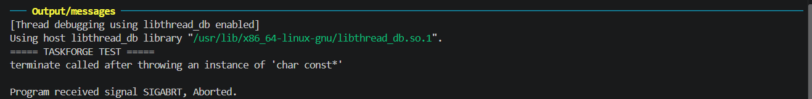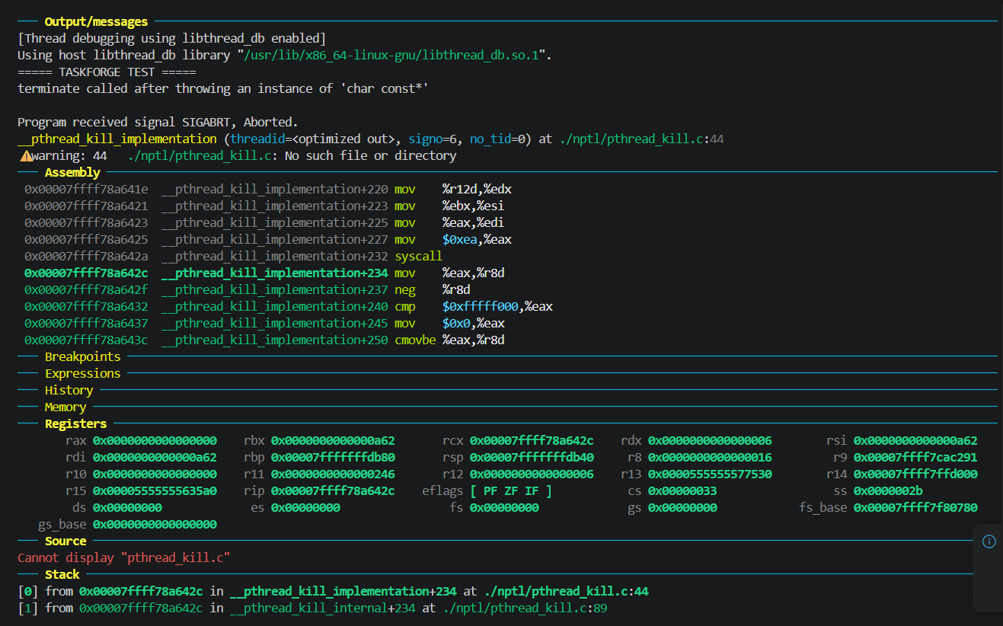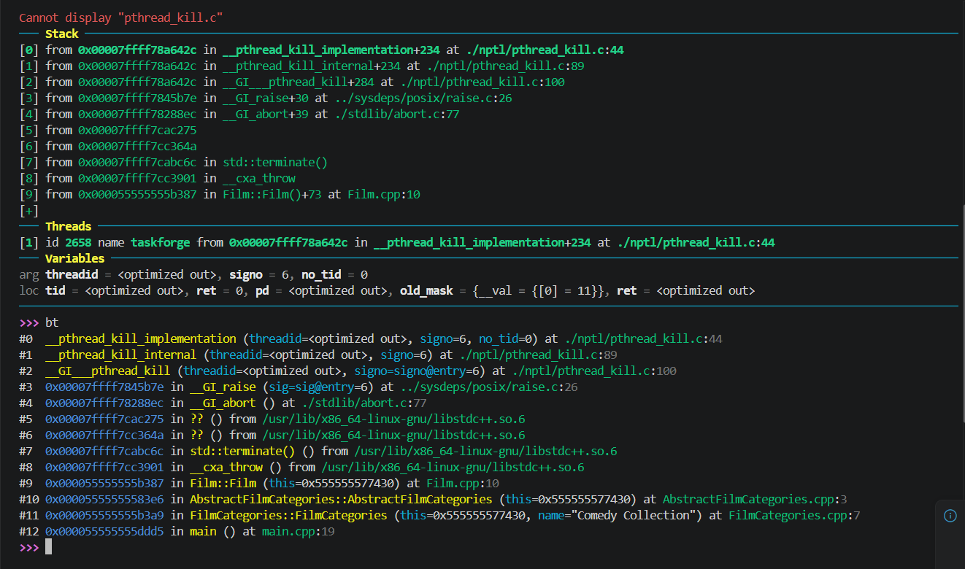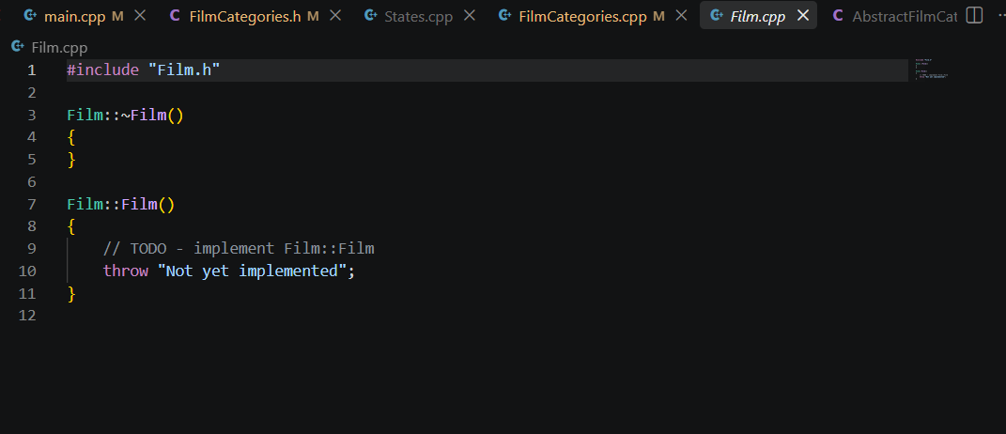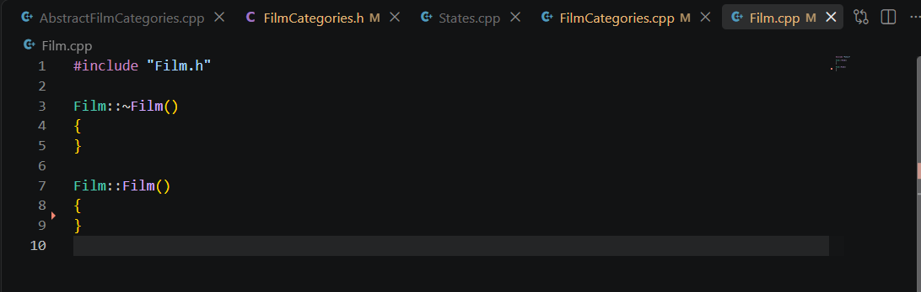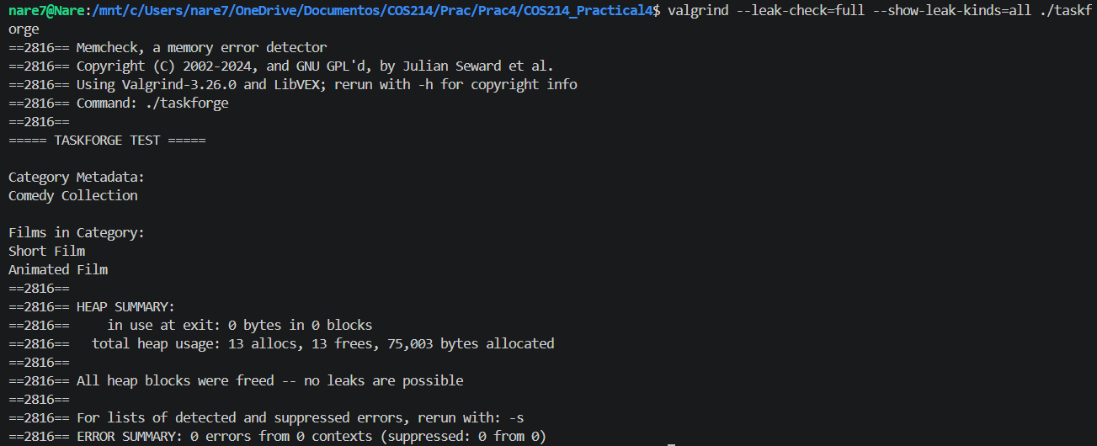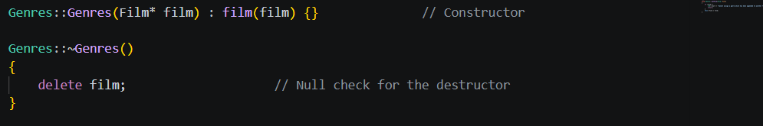

VALGRIND EVIDENCE

valgrind --leak-check=full --show-leak-kinds=all ./taskforge
==4343== Memcheck, a memory error detector
==4343== Copyright (C) 2002-2024, and GNU GPL'd, by Julian Seward et al.
==4343== Using Valgrind-3.26.0 and LibVEX; rerun with -h for copyright info
==4343== Command: ./taskforge
==4343==
========== TASKFORGE TEST ==========

=== CATEGORY INFO ===
Comedy Collection

=== ALL FILMS ===
Short Film
Animated Film
Blockbuster Film

=== STATE TRANSITION ===
Before: Development
After: Production

=== PRODUCTION FILMS ===
Short Film

=== MOVING FILM ===

Comedy Collection:
Short Film
Blockbuster Film

Featured Collection:
Animated Film

========== END OF DEMO ==========
==4343==
==4343== HEAP SUMMARY:
==4343== in use at exit: 8 bytes in 1 blocks
==4343== total heap usage: 26 allocs, 25 frees, 75,336 bytes allocated
==4343==
==4343== 8 bytes in 1 blocks are definitely lost in loss record 1 of 1
==4343== at 0x485CFD3: operator new(unsigned long) (vg_replace_malloc.c:488)
==4343== by 0x4007EFC: FilmTypes::FilmTypes() (FilmTypes.cpp:8)
==4343== by 0x4008341: ShortFilm::ShortFilm() (FilmTypes.cpp:61)
==4343== by 0x4009E76: main (main.cpp:26)
==4343==
==4343== LEAK SUMMARY:
==4343== definitely lost: 8 bytes in 1 blocks
==4343== indirectly lost: 0 bytes in 0 blocks
==4343== possibly lost: 0 bytes in 0 blocks
==4343== still reachable: 0 bytes in 0 blocks
==4343== suppressed: 0 bytes in 0 blocks
==4343==
==4343== For lists of detected and suppressed errors, rerun with: -s
==4343== ERROR SUMMARY: 1 errors from 1 contexts (suppressed: 0 from 0)

